727721euit002

SOFTWARE TESTING- CIA-2

ABINAYA.S

A travel website that allows users to search and book for stay online. Design a test suite to test the  
functionality using Selenium. Consider different test scenarios such selecting the check in and checkout,  
place of stay and other preferences using TestNG.Generate TestNG report.  
Question 1 (1*25=25)  
1. Verify that the user can enter the location of stay  
2. Verify user can select the check in and checkout date  
3. Select the number of rooms and guests based on your preference  
4. Verify if user is able to check the pet friendly checkbox under rooms dropdown and click on search  
5. Select the price range ,property type as hotel and guest rating 8.5  
6. Apply more filters by selecting breakfast included,wifi,pool

1.CODE:

public class CA2 {

@Test

public void f()throws InterruptedException {

WebDriverManager.chromedriver().setup();

WebDriver driver;

ChromeOptions co = new ChromeOptions();

co.addArguments("--remote-allow-origins=*");

driver=new ChromeDriver(co);

driver.manage().window().maximize();

driver.get("https://www.trivago.in/");

Thread.sleep(2000);

String actualTitle="trivago.in - Compare hotel prices worldwide";

String extractedTitle=driver.getTitle();

AssertJUnit.assertEquals(actualTitle, extractedTitle);

System.out.println("Page title is Validated.");

Thread.sleep(2000);

WebElement location=driver.findElement(By.xpath("//*[@id=\"__next\"]/div[1]/div[1]/section/div[2]/div[3]/div/div[1]/div/form/div"));

location.click();

Thread.sleep(2000);

WebElement ben=driver.findElement(By.xpath("//*[@id=\"suggestion-list\"]/ul/li[1]/div/div"));

ben.click();

Thread.sleep(2000);

WebElement cin=driver.findElement(By.xpath("//*[@id=\"__next\"]/div[1]/div[1]/section/div[2]/div[3]/div/div[2]/div/div/div/div[2]/div/div[1]/div[2]/button[2]/time"));

cin.click();

Thread.sleep(2000);

// WebElement coutcol=driver.findElement(By.xpath("//*[@id=\"__next\"]/div[1]/div[1]/section/div[2]/div[3]/div/div[1]/fieldset/button[2]/span"));

// coutcol.click();

WebElement cout=driver.findElement(By.xpath("//*[@id=\"__next\"]/div[1]/div[1]/section/div[2]/div[3]/div/div[2]/div/div/div/div[2]/div/div[1]/div[2]/button[7]/time"));

cout.click();

Thread.sleep(2000);

WebElement inc=driver.findElement(By.xpath("//*[@id=\"__next\"]/div[1]/div[1]/section/div[2]/div[3]/div/div[2]/div/div/div[1]/div/div[1]/div[1]/div/button[2]/span/span[1]"));

inc.click();

inc.click();

inc.click();

Thread.sleep(2000);

WebElement pet=driver.findElement(By.id("checkbox-13"));

pet.click();

Thread.sleep(3000);

WebElement apply=driver.findElement(By.xpath("//*[@id=\"__next\"]/div[1]/div[1]/section/div[2]/div[3]/div/div[2]/div/div/div[2]/div/button[2]"));

apply.click();

Thread.sleep(3000);

if(driver.getTitle().equals("Bengaluru (Pet friendly) Hotels | Find & compare great deals on trivago")) {

System.out.println("1.Verified that the user can enter the location of stay.");

System.out.println("2.Verified that the user can select the check-in and check-out date.");

System.out.println("3.Verified that the user can enter the no of rooms based on their preference.");

}

}

}

package com.selenium.test2.selenium1; import [org.openqa.selenium.By](http://org.openqa.selenium.By); import org.openqa.selenium.Keys; import org.openqa.selenium.WebDriver; import org.openqa.selenium.WebElement; import org.openqa.selenium.chrome.ChromeDriver; import org.openqa.selenium.chrome.ChromeOptions; import org.testng.AssertJUnit; import org.testng.annotations.Test; import io.github.bonigarcia.wdm.WebDriverManager; public class CA2 { WebDriver driver; @Test public void f() throws InterruptedException { WebDriverManager.chromedriver().setup(); ChromeOptions co=new ChromeOptions(); co.addArguments("--remote-allow-origins=*"); WebDriver driver=new ChromeDriver(co); driver.get("<https://www.trivago.in/>"); driver.manage().window().maximize(); driver.findElement(By.xpath("//*[@id=\"__next\"]/div[1]/div[1]/section/div[2]/div[3]/div/div[1]/div/form/div")).click(); WebElement search = driver.findElement(By.xpath("//*[@id=\"input-auto-complete\"]")); search.sendKeys("Chennai"); driver.findElement(By.xpath("//*[@id=\"__next\"]/div[1]/div[1]/section/div[2]/div[3]/div/div[1]/fieldset/button[1]")).click(); driver.findElement(By.xpath("//*[@id=\"__next\"]/div[1]/div[1]/section/div[2]/div[3]/div/div[2]/div/div/div/div[3]/ul/li[2]/label")).click(); driver.findElement(By.xpath("//*[@id=\"__next\"]/div[1]/div[1]/section/div[2]/div[3]/div/div[2]/div/div/button")).click(); driver.findElement(By.xpath("//*[@id=\"__next\"]/div[1]/div[1]/section/div[2]/div[3]/div/div[1]/fieldset/button[2]")).click(); driver.findElement(By.xpath("//*[@id=\"__next\"]/div[1]/div[1]/section/div[2]/div[3]/div/div[2]/div/div/div/div[3]/ul/li[3]/label")).click(); driver.findElement(By.xpath("//*[@id=\"__next\"]/div[1]/div[1]/section/div[2]/div[3]/div/div[2]/div/div/button")).click(); driver.findElement(By.xpath("//*[@id=\"__next\"]/div[1]/div[1]/section/div[2]/div[3]/div/div[1]/button")).click(); driver.findElement(By.xpath("//*[@id=\"__next\"]/div[1]/div[1]/section/div[2]/div[3]/div/div[2]/div/div/div[1]/div/div[2]/div[2]")).click(); driver.findElement(By.xpath("//*[@id=\"__next\"]/div[1]/div[1]/section/div[2]/div[3]/div/div[2]/div/div/div[2]/div/button[2]")).click(); driver.findElement(By.xpath("//*[@id=\"__next\"]/div[1]/div[1]/section/div[2]/div[3]/div/button")).click(); }

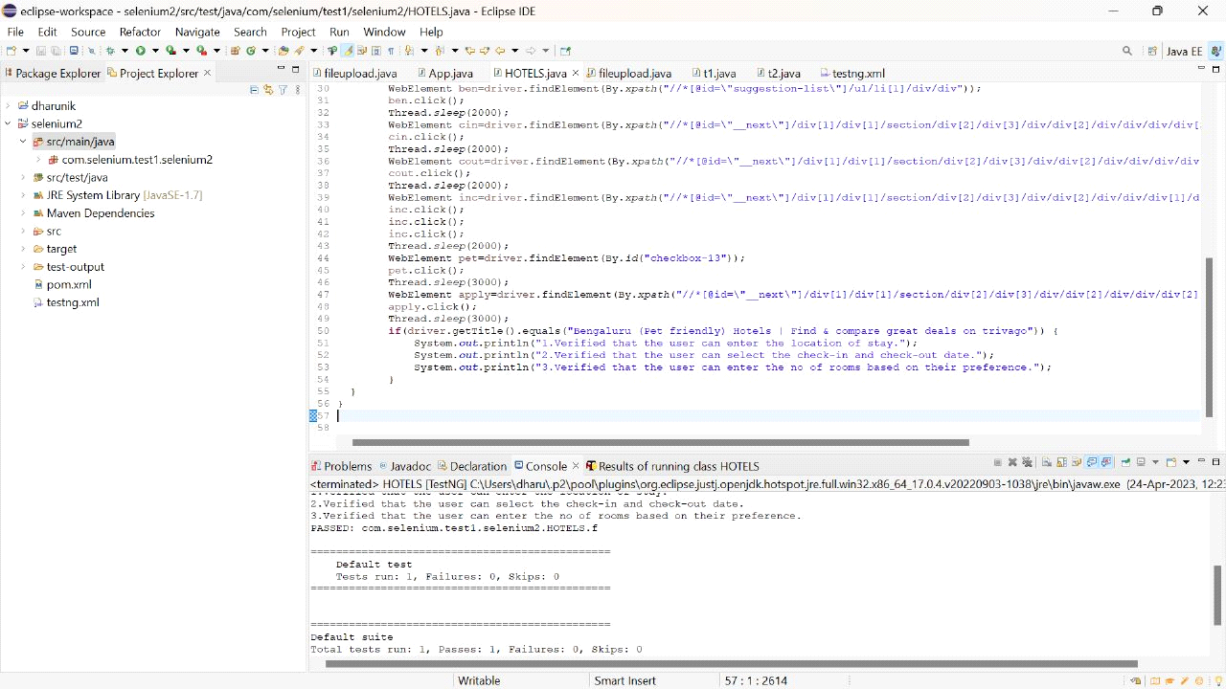

2.

Question 2 (1*20=20)  
1. Sort the hotels by “Price and Recommendations”  
2. Print the 1st hotel name along with price  
3. Sort the hotels by “price”  
4. Print the name along with price  
5. Print the number of stays found  
6. Print the number of Booking sites searched

package com.selenium.test2.selenium1; import [org.openqa.selenium.By](http://org.openqa.selenium.By); import org.openqa.selenium.Keys; import org.openqa.selenium.WebDriver; import org.openqa.selenium.WebElement; import org.openqa.selenium.chrome.ChromeDriver; import org.openqa.selenium.chrome.ChromeOptions; import org.testng.AssertJUnit; import org.testng.annotations.Test; import io.github.bonigarcia.wdm.WebDriverManager; public class CA2 { WebDriver driver; @Test public void f() throws InterruptedException { WebDriverManager.chromedriver().setup(); ChromeOptions co=new ChromeOptions(); co.addArguments("--remote-allow-origins=*"); WebDriver driver=new ChromeDriver(co); driver.get("<https://www.trivago.in/>"); driver.manage().window().maximize(); driver.findElement(By.xpath("//*[@id=\"__next\"]/div[1]/div[1]/section/div[2]/div[3]/div/div[1]/div/form/div")).click(); WebElement search = driver.findElement(By.xpath("//*[@id=\"input-auto-complete\"]")); search.sendKeys("Chennai"); driver.findElement(By.xpath("//*[@id=\"__next\"]/div[1]/div[1]/section/div[2]/div[3]/div/div[1]/fieldset/button[1]")).click(); driver.findElement(By.xpath("//*[@id=\"__next\"]/div[1]/div[1]/section/div[2]/div[3]/div/div[2]/div/div/div/div[3]/ul/li[2]/label")).click(); driver.findElement(By.xpath("//*[@id=\"__next\"]/div[1]/div[1]/section/div[2]/div[3]/div/div[2]/div/div/button")).click(); driver.findElement(By.xpath("//*[@id=\"__next\"]/div[1]/div[1]/section/div[2]/div[3]/div/div[1]/fieldset/button[2]")).click(); driver.findElement(By.xpath("//*[@id=\"__next\"]/div[1]/div[1]/section/div[2]/div[3]/div/div[2]/div/div/div/div[3]/ul/li[3]/label")).click(); driver.findElement(By.xpath("//*[@id=\"__next\"]/div[1]/div[1]/section/div[2]/div[3]/div/div[2]/div/div/button")).click(); driver.findElement(By.xpath("//*[@id=\"__next\"]/div[1]/div[1]/section/div[2]/div[3]/div/div[1]/button")).click(); driver.findElement(By.xpath("//*[@id=\"__next\"]/div[1]/div[1]/section/div[2]/div[3]/div/div[2]/div/div/div[1]/div/div[2]/div[2]")).click(); driver.findElement(By.xpath("//*[@id=\"__next\"]/div[1]/div[1]/section/div[2]/div[3]/div/div[2]/div/div/div[2]/div/button[2]")).click(); driver.findElement(By.xpath("//*[@id=\"__next\"]/div[1]/div[1]/section/div[2]/div[3]/div/button")).click(); }

OUTPUT:

